Scott County Fiscal Court held a meeting on Thursday, January 25, 2024. Judge Covington called the meeting to order. Present were Magistrates Mr. Hostetler, Mr. Jones, Mr. Wallace, Mr. Corman, Mr. Ellison, Mr. Pratt, Mr. Livingston, and County Attorney, Cam Culbertson.
A motion was made by Mr. Livingston with second by Mr. Hostetler to approve the previous meeting minutes. Court voted unanimous.
A motion was made by Mr. Hostetler with second by Mr. Corman to approve the following transfers. Court voted unanimous.
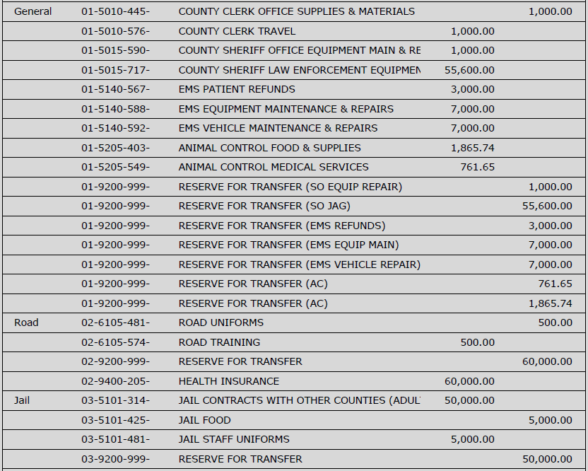
A motion was made by Mr. Hostetler with second by Mr. Jones to approve the bills as presented and the following hand check. Court voted unanimous.
Road Fund/ General $200,000.00
A motion was made by Mr. Pratt with second by Mr. Ellison to reappoint all county employees. Court voted unanimous.
Mr. Hostetler introduced guests to discuss the NET Recovery device; neurostimulation therapy used for the treatment of opioid use disorder. He urged court members to support using opioid settlement funds to conduct a study which will include thirty-four Scott County, Kentucky participants with the NET device.
Mr. Ellison left.
Mr. Wallace left.
Mr. Ellison returned.
Mr. Culbertson reviewed the agreement; a termination statement will be added. Mr. Pratt stated due to current medical evidence he can’t support the proposal, but hopes it is successful. A motion was made by Mr. Hostetler with second by Mr. Jones to approve the agreement. Voting Yes: Mr. Hostetler, Mr. Jones, Mr. Corman, Mr. Ellison, Mr. Livingston, Judge Covington. Voting No: Mr. Pratt. Motion carries.
Mr. Culbertson read Resolution 24-02; a resolution authorizing Scott County Fiscal Court to provide local match funding and serve as the grantee for the Kentucky Product Development Initiative grant as awarded for the Lanes Run Business Park phase III project. A motion was made by Mr. Ellison with second by Mr. Jones to approve the resolution. Court voted unanimous.
Mr. Culbertson read Resolution 24-03; a resolution approving a professional services agreement for the regional Kentucky Product Development Initiative project. A motion was made by Mr. Pratt with second by Mr. Livingston to approve the resolution. Mr. Hostetler abstained. Court voted unanimous.
Mr. Culbertson read Resolution 24-04; a resolution of Scott County Fiscal Court authorizing the judge/executive to sign documents necessary for the formation of a regional industrial development authority. A motion was made by Mr. Jones with second by Mr. Corman to approve the resolution. Court voted unanimous.
Fire Chief, John Ward requested an acting assignment due to an employee’s resignation. Tyler Woolums will temporarily serve as Lieutenant at $15.20 per hour. A motion was made by Mr. Livingston with second by Mr. Pratt to approve the assignment. Court voted unanimous.
EMS Director, Chris Runyon requested to hire Sarah Bowman full-time at 13.46 per hour and Logan Burke part-time at $11.48 per hour. A motion was made by Mr. Hostetler with second by Mr. Ellison to approve the new hires. Court voted unanimous.
Road Department Director, J.R. Brandenburg requested to hire Bradly Wiley full-time at $18.35 and William Fields full-time at $23.16 per hour. A motion was made by Mr. Hostetler with second by Mr. Jones to approve the new hires. Court voted unanimous.
Chief Ward stated it is time to bid the installation project for the generators purchased last year. A motion was made by Mr. Hostetler with second by Mr. Jones to approve advertisement. Court voted unanimous.
A motion was made by Mr. Livingston with second by Mr. Pratt to adjourn. Court voted unanimous.

